Time Taken and Graphs

1. Insertion Sort (mit 8 Messwerte)

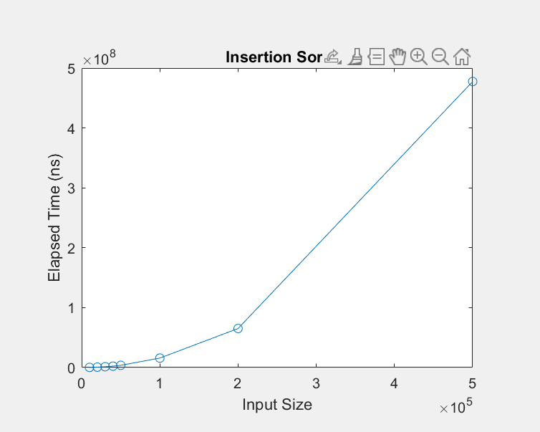

Elapsed Time in nano seconds: for size 10000 Insertion Sort 162185

Elapsed Time in nano seconds: for size 20000 Insertion Sort 648192

Elapsed Time in nano seconds: for size 30000 Insertion Sort 1342893

Elapsed Time in nano seconds: for size 40000 Insertion Sort 2319607

Elapsed Time in nano seconds: for size 50000 Insertion Sort 3720076

Elapsed Time in nano seconds: for size 100_000 Insertion Sort 15771604

Elapsed Time in nano seconds: for size 200_000 Insertion Sort 65159020

Elapsed Time in nano seconds: for size 500_000 Insertion Sort 477515441

1. Selection Sort(mit 8 Messwerte)

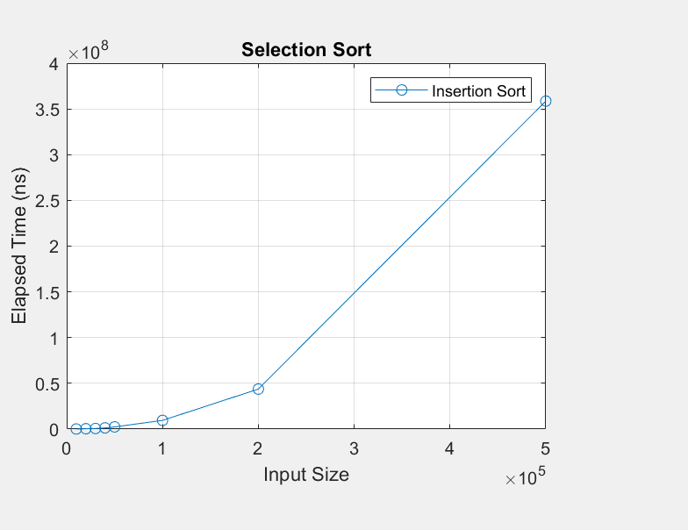

Elapsed Time in nano seconds: for size 10000 Selection Sort 97569

Elapsed Time in nano seconds: for size 20000 Selection Sort 396139

Elapsed Time in nano seconds: for size 30000 Selection Sort 633712

Elapsed Time in nano seconds: for size 40000 Selection Sort 1306592

Elapsed Time in nano seconds: for size 50000 Selection Sort 2400128

Elapsed Time in nano seconds: for size 100_000 Selection Sort 9488438

Elapsed Time in nano seconds: for size 200_000 Selection Sort 43748876

Elapsed Time in nano seconds: for size 500_000 Selection Sort 358573711

1. Bubble Sort(mit 8 punkte)

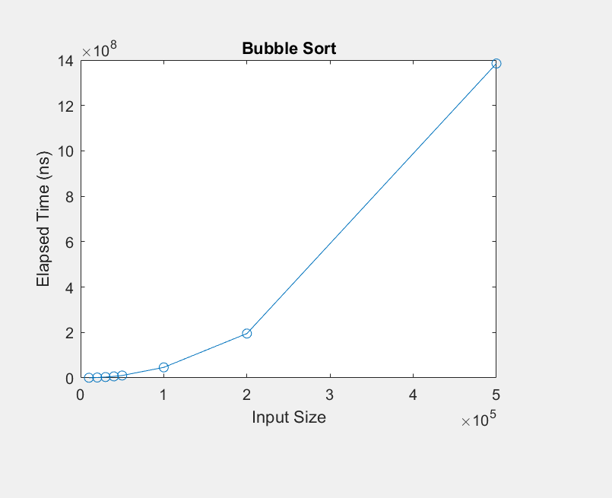

Elapsed Time in nano seconds: for size 10000 Bubble Sort 412338

Elapsed Time in nano seconds: for size 20000 Bubble Sort 1639322

Elapsed Time in nano seconds: for size 30000 Bubble Sort 3670832

Elapsed Time in nano seconds: for size 40000 Bubble Sort 6630650

Elapsed Time in nano seconds: for size 50000 Bubble Sort 10473918

Elapsed Time in nano seconds: for size 100_000 Bubble Sort 46190899

Elapsed Time in nano seconds: for size 200_000 Bubble Sort 195337838

Elapsed Time in nano seconds: for size 500_000 Bubble Sort 1384895683

1. Quick sort(mit 10 Messwerte)

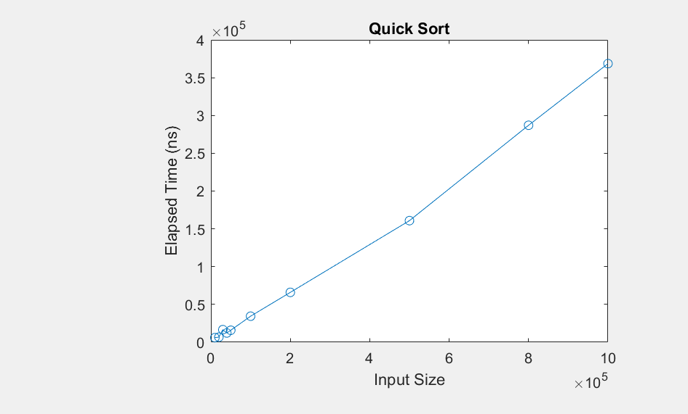

Elapsed Time in nano seconds: for size 10000 Quick Sort 6062

Elapsed Time in nano seconds: for size 20000 Quick Sort 6721

Elapsed Time in nano seconds: for size 30000 Quick Sort 16611

Elapsed Time in nano seconds: for size 40000 Quick Sort 12222

Elapsed Time in nano seconds: for size 50000 Quick Sort 15838

Elapsed Time in nano seconds: for size 100_000 Quick Sort 34439

Elapsed Time in nano seconds: for size 200_000 Quick Sort 65969

Elapsed Time in nano seconds: for size 500_000 Quick Sort 160872

Elapsed Time in nano seconds: for size 800_000 Quick Sort 287032

Elapsed Time in nano seconds: for size 1000_000 Quick Sort 368597

1. Merge(mit 10 messwerte)

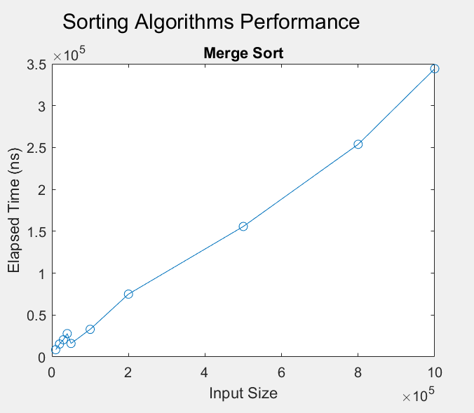

Elapsed Time in nano seconds: for size 10000 MergeSort 8627

Elapsed Time in nano seconds: for size 20000 MergeSort 15426

Elapsed Time in nano seconds: for size 30000 MergeSort 20513

Elapsed Time in nano seconds: for size 40000 MergeSort 27796

Elapsed Time in nano seconds: for size 50000 MergeSort 16068

Elapsed Time in nano seconds: for size 100_000 MergeSort 32948

Elapsed Time in nano seconds: for size 200_000 MergeSort 74953

Elapsed Time in nano seconds: for size 500_000 MergeSort 155741

Elapsed Time in nano seconds: for size 800_000 MergeSort 253843

Elapsed Time in nano seconds: for size 1000_000 MergeSort 344131